FACTSHEET No. 20
CALORIES IN BREAD

Background

There are over 5.5 million sliced and wrapped loaves sold on average in the UK every day.

Bread is one of our staple foods and it has been around for thousands of years. It makes an important contribution to our diet not only as a great source of carbohydrate but also providing protein, fibre and valuable micronutrients.

The National Diet and Nutrition Survey (NDNS) is a national survey of the dietary habits and nutritional status of the UK population. Results from this survey indicate that bread accounts on average for 11% of adult food energy intake, 11% of protein and nearly 20% of fibre, but only 5% of fat intake.

The results also show that bread provides more than 15% of adult dietary intake of calcium and iron, and over 10% of zinc, magnesium, selenium and folate.

The Government’s Eatwell Guide³ shows the UK food based dietary recommendations. It is a model of the different types of food, and the proportions we should eat them in, to have a well-balanced and healthy diet. Bread is included in the Potatoes, bread, rice, pasta and other starchy carbohydrates section which should make up about a third of our diet. It is recommended to choose whole grain or higher fibre varieties.

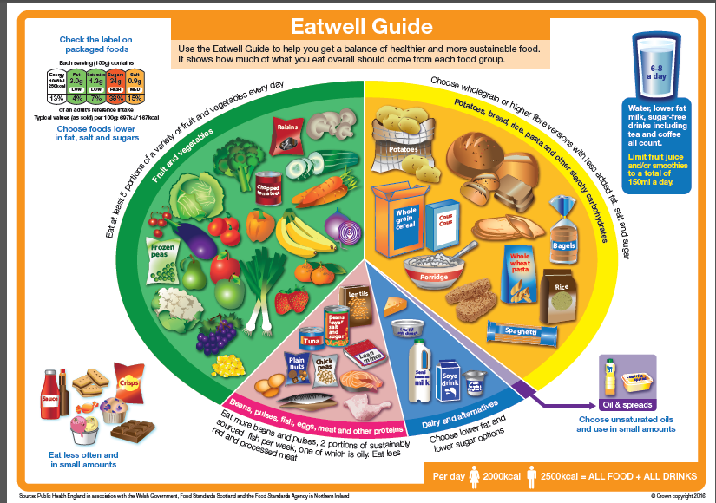

Energy, Fat & Sugar Content of Different Types of Bread:
Starchy foods are a good source of energy but some people think they are fattening. Most bread in the UK is low in fat and sugars.
The table below shows the typical calories, fat and sugar in a white, brown and wholemeal breads.

 | White  (per 100g) | Per slice* | Brown  (per 100g) | Per Slice* | Wholemeal  (per 100g) | Per slice*
Energy | 219kcal | 83 kcal | 207kcal | 79 kcal | 217kcal | 82 kcal
Fat | 1.6g | 0.6g | 2.0g | 0.8g | 2.5g | 1.0g
Total Sugars | 3.4g | 1.3g | 3.4g | 1.3g | 2.8g | 1.1g

Based on McCance and Widdowson Composition of Foods 7th Edition (2014) information for ‘per 100g’ of bread and per slice information calculate using a typical slice weight of 38g

Q&A’s

How many calories are there in bread?
According to McCance and Widdowson’s ‘The Composition of Foods’⁴, an average white bread has 219 calories per 100g and an average wholemeal bread has 217 calories per 100g. For a 38g slice of bread this would equate to 83 calories for white and 82 calories for wholemeal bread.

Is bread fattening?
Being overweight is caused by an imbalance where energy intake (food eaten) exceeds energy expenditure (physical activity). Bread has had some bad press as a result of some of the anti-carb celebrity diet crazes, but carbohydrates are necessary for a healthy balanced diet and higher fibre versions can actually help you by keeping you feeling full (and so less likely to snack). Carbohydrates provide fewer calories per gram of food than fat (carbohydrates provide 4kcal per gram, while fat provides 9 kcal per gram).

Most bread in the UK is low in fat and sugars, with less than 3% fat and less than 5% sugars. An average slice of bread has less than 100 calories.

It is important to be careful with choices of spreads and to be smarter with our choices of fillings and toppings as these are what often add to the fat and calorie content. For example, fill sandwiches with lean cuts of meat like chicken breast, fish such as tuna, and add salad.

How much bread should be included in a healthy diet?
Starchy foods, such as bread, potatoes, cereals, rice and pasta, are our main source of carbohydrate and play an important role in a healthy diet. These foods should make up about a third of the food we eat.

Bread, especially wholemeal, malted grain/granary, brown and seeded breads, is a healthy choice to eat as part of a balanced diet.

Wholegrain, wholemeal and brown breads give us energy and contain B vitamins, vitamin E, fibre and a wide range of minerals. White bread also contains a range of vitamins and minerals, and although it has less fibre than whole grain, wholemeal or brown breads, it still has about 2.5% (compared to wholemeal at around 7%).

Are there any lower calorie breads available?

Yes, there are a number of bread products available in the UK that have a lower calorie count per slice.

⁴ McCance and Widdowson Composition of Foods 7th Edition (2014)

Nielsen Total UK Coverage, Unit Sales 52w /e 16.08.14.
National Diet and Nutrition Survey Years 5 and 6 (combined) of the UK NDNS Rolling Programme (2012/13 – 2013/14) ³ PHE Eatwell Guide https://www.gov.uk/government/publications/the-eatwell-guide

